[Date]

Dheeraj Krishna Banna

[company name]

[Document title]

[Document subtitle]

Contents

Introduction 2

Requirements 2

Entities: 3

Entities and their attributes: 3

ER Diagram: 4

Database Design: 5

Creating Tables with Columns 5

Data Integrity 9

Data Dictionary: 9

Data generation and Loading: 12

Performance Tuning: 13

Indexing 13

Query Writing: 16

Data visualisation: 18

Conclusion: 18

# Introduction

A hospital database is a comprehensive and organized collection of information related to a hospital's operations, patient care, medical procedures, and other healthcare-related activities. The database is designed to manage and store large amounts of data securely, accurately, and efficiently. It serves as a critical tool for healthcare providers to access and manage patient records, medical histories, diagnostic test results, and other relevant information to provide high-quality care.

The hospital database includes various modules, such as patient registration, medical history, appointment scheduling, pharmacy, laboratory, radiology, billing, and more. The database can be accessed by authorized healthcare personnel, including doctors, nurses, administrative staff, and other medical professionals, to retrieve and update patient records, track medical procedures, and monitor the progress of patients' treatment.

With the help of a hospital database, healthcare providers can improve patient care, reduce medical errors, increase efficiency, and better manage resources. It is a critical component of modern healthcare systems and plays a vital role in delivering quality healthcare services.

# Requirements

Claim table: This table gives the information about the people and what they claimed for about their medical condition.

Degree Table: This table gives the information about the doctor’s type and level of education degree. In which degree they have been specialized.

Department Table: This table gives the information about doctors and patients assigned to different type of medical departments like Neurology, Nephrology, Cardiology etc.

Doctor Table: This table gives the information about All the information about doctor like Name, Contact Number, Address, Department etc.

Insurance company Table: This table gives the information about name, Type and level of insurance company and the patient associated with that company.

Nurse Table: This table gives the information about name and degree and the information of the nurses.

Operation Table: This table gives the information about the patient’s name and name of the operation and the doctor performing the operation.

Operation Type Table: This table gives the information about the operation type and the cost of the operation.

Patient Table: This table gives all the information about the patient like Name of the patient and Contact Number, Address Etc.

# Entities:

* Claim
* Degree
* Department
* Doctor
* Insurance_Company
* Nurse
* Operation
* Operatin_Type
* Patient

# Entities and their attributes:

* Claim
  + Claim_Number
  + Company_Name
  + Patient_Number
  + Diagnosis
  + Amount
* Degree
  + Doctor_Number
  + Degree_type
  + Major
  + University
  + Year_Grad
* Department
  + Departmennt_number
  + Department_Office_Number
  + Department_Telephone
* Doctor
  + Department_Number
  + Doctor_number
  + Doctor_FirstName
  + Doctor_LastName
  + Doctor_Office_Number
  + Doctor_Telephone
  + BackUp_Doc
* Insurance_Company
  + Company_Name
  + Telephone
  + City
  + State
* Nurse
  + Department_Number
  + Nurse_Number
  + Nurse_FirstName
  + Nurse_LastName
  + Certification
  + Year_Hired
  + Supervised_ID
* Operation
  + Patient_Number
  + Doctor_Number
  + Operation_Name
  + Date_of_op
  + Start_Time
  + End_Time
  + Operating_Room_no
* Operatin_Type
  + Operation_Name
  + Duration
  + Cost
* Patient
  + Patient_Number
  + Patient_FirstName
  + Patient_LastName
  + House
  + Street
  + City
  + State

# ER Diagram:

# Database Design:

## Creating Tables with Columns

Below is the query we used to create tables and columns. Each table has a primary given

CREATE TABLE Department(

Department_Number Numeric(3,0) identity(100,1) NOT NULL,

Department_Office_Number Numeric(3,0) NOT NULL,

Department_Telephone Varchar(15) NOT NULL,

CONSTRAINT PK_Department_Number PRIMARY KEY (Department_Number)

);

CREATE TABLE Nurse(

Department_Number Numeric(3,0) NOT NULL,

Nurse_Number Numeric(10,0) identity(1000000000,1) NOT NULL,

Nurse_FirstName Varchar(100) NOT NULL,

Nurse_LastName Varchar(100) NOT NULL,

Certification Varchar(100) NOT NULL,

Year_Hired Datetime NOT NULL,

Supervisor_ID Numeric(10,0),

CONSTRAINT PK_Nurse_Number PRIMARY KEY (Nurse_Number),

CONSTRAINT FK_Department_Number FOREIGN KEY (Department_Number) REFERENCES Department(Department_Number),

CONSTRAINT FK_Supervisor FOREIGN KEY (Supervisor_ID) REFERENCES Nurse(Nurse_Number)

);

CREATE TABLE Doctor(

Department_Number Numeric(3,0) NOT NULL,

Doctor_Number Numeric(10,0)identity(1000000000,1) NOT NULL,

Doctor_FirstName Varchar(100) NOT NULL,

Doctor_LastName Varchar(100) NOT NULL,

Doctor_Office_Number Numeric(3,0),

Doctor_Telephone Varchar(15) NOT NULL,

BackUp_Doc Numeric(10,0)

CONSTRAINT PK_Doctor_Number PRIMARY KEY (Doctor_Number),

CONSTRAINT FK_Department_Number_Doc FOREIGN KEY (Department_Number) REFERENCES Department(Department_Number),

CONSTRAINT FK_BackupDoctor FOREIGN KEY (BackUp_Doc) REFERENCES Doctor(Doctor_Number)

);

CREATE TABLE Degree(

Doctor_Number Numeric(10,0) NOT NULL,

Degree_Type VarChar(10) NOT NULL,

Major Varchar(60) NOT NULL,

University Varchar(80) NOT NULL,

Year_Grad date ,

CONSTRAINT PK_Doctor_Number_and_Degree_Type PRIMARY KEY (Doctor_Number,Degree_Type),

CONSTRAINT FK_Doctor_Number FOREIGN KEY (Doctor_Number) REFERENCES Doctor(Doctor_Number)

);

CREATE TABLE Patient(

Patient_Number Numeric(15,0) identity(100000000000000,1) NOT NULL,

Patient_FirstName Varchar(50) NOT NULL,

Patient_LastName VarChar(50) NOT NULL,

House VarChar (50) NOT NULL,

Street VarChar (40) NOT NULL,

City VarChar (40) NOT NULL,

State_ VarChar (40)

CONSTRAINT PK_Patient_Number PRIMARY KEY (Patient_Number)

);

CREATE TABLE Operation_Type(

Operation_Name VarChar (100) NOT NULL,

Duration Numeric (2,2) NOT NULL,

Cost Numeric (7,3) NOT NULL,

CONSTRAINT PK_Operation_Name PRIMARY KEY (Operation_Name)

);

CREATE TABLE Operation(

Patient_Number Numeric (15,0) NOT NULL,

Doctor_Number Numeric (10,0) NOT NULL,

Operation_Name Varchar(100) NOT NULL,

Date_of_Op Datetime NOT NULL,

Start_Time Time NOT NULL,

End_Time Time NOT NULL,

Operating_Room_No Numeric(5,0)NOT NULL,

CONSTRAINT PK_Patient_Number_Composite PRIMARY KEY (

Patient_Number,Doctor_Number,Operation_Name,Date_of_Op),

CONSTRAINT FK_Patient_FK_ FOREIGN KEY (Patient_Number) REFERENCES Patient(Patient_Number),

CONSTRAINT FK_Doctor_Number__ FOREIGN KEY (Doctor_Number) REFERENCES Doctor(Doctor_Number),

CONSTRAINT FK_Operation_Name FOREIGN KEY (Operation_Name) REFERENCES Operation_Type(Operation_Name),

);

CREATE TABLE Insurance_Company(

Company_Name VarChar (70),

Telephone VARCHAR (15),

City VarChar (40),

State_ VarChar (40),

CONSTRAINT PK_Company_Name PRIMARY KEY (Company_Name)

);

CREATE TABLE Claim(

Claim_Number Int IDENTITY (1,1) NOT NULL,

Company_Name VarChar (70) NOT NULL,

Patient_Number Numeric (15,0) NOT NULL,

Diagnosis VarChar(80) NOT NULL,

Amount Numeric (7,3),

CONSTRAINT PK_Claim_Number PRIMARY KEY (Claim_Number),

CONSTRAINT FK_Patient_Number__ FOREIGN KEY (Patient_Number) REFERENCES Patient(Patient_Number),

CONSTRAINT FK_Company_Name__ FOREIGN KEY (Company_Name) REFERENCES Insurance_Company(Company_Name)

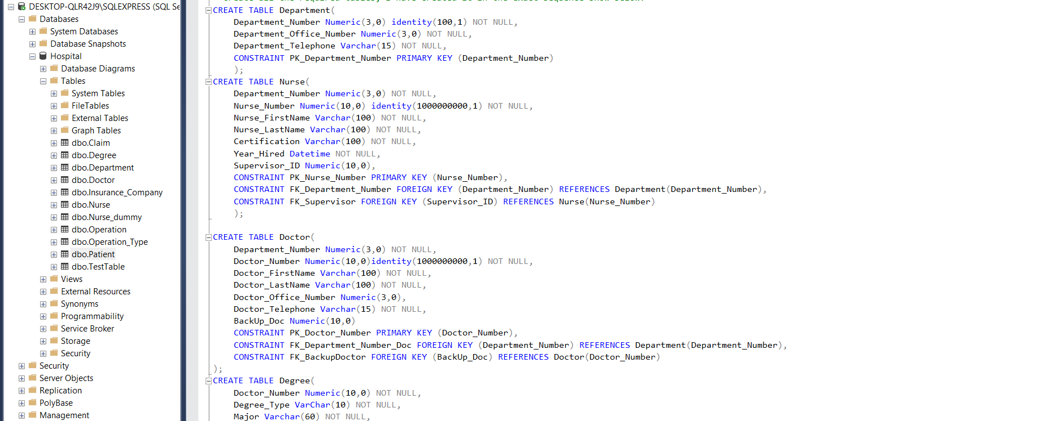

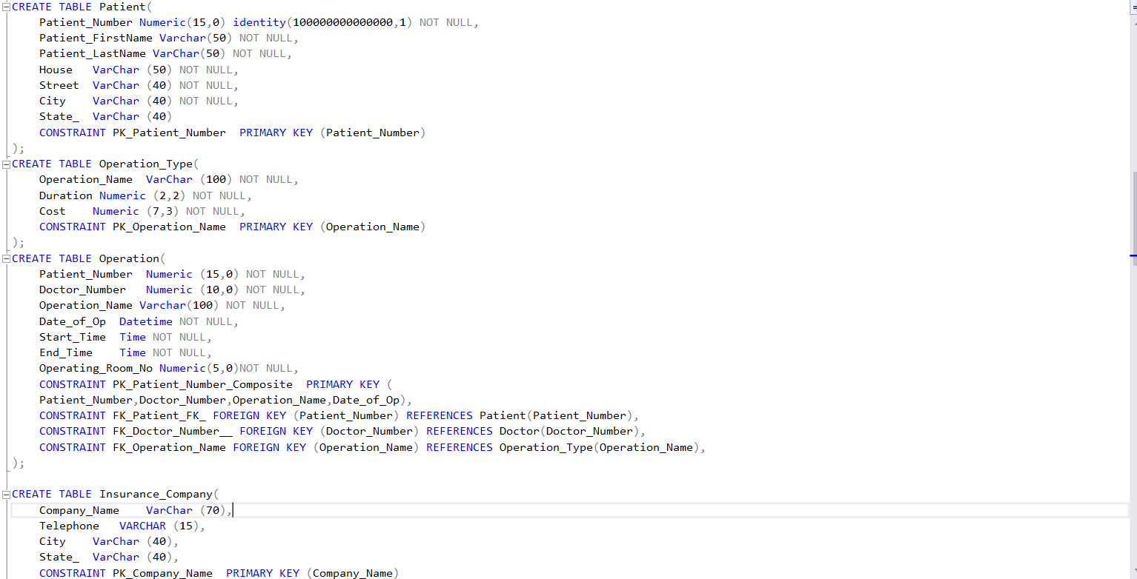

A new table in the database can be created by using CREATE command and when a new

table is created by utilizing an existing table, the new table will be loaded with the old

table's existing values.

## Data Integrity

Data Integrity refers to the consistency and maintenance of the data through the life cycle of the database. In a database, data integrity can be ensured through the implementation of Integrity Constraints in a table. Integrity constraints help apply business rules to the database tables. The constraints can either be at a column level or a table level. Some of the most common constraints are,

• NOT NULL – Prevents a column from having a NULL value.

• PRIMARY KEY – Uniquely identifies each row or record in table.

• FOREIGN KEY – Uniquely identifies a column that references a PRIMARY KEY in another table.

• UNIQUE – Prevents a column from having duplicate values.

• CHECK – Checks for values that satisfy a specific condition as defined by the user.

## Data Dictionary:

The Data Dictionary for the Doctor Table

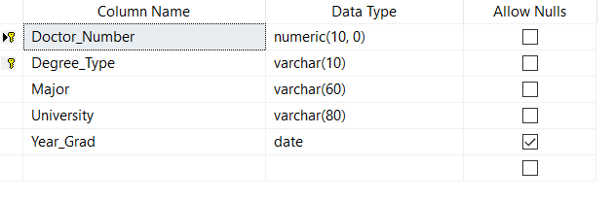

The Data Dictionary for the Department Table

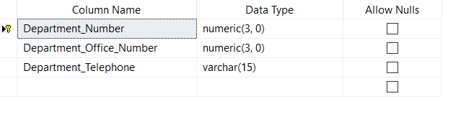

The Data Dictionary for the Doctor Table

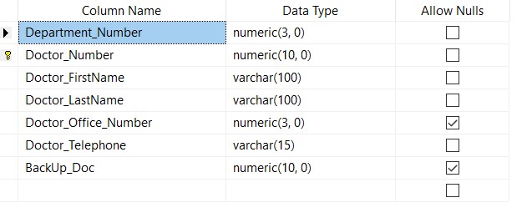

The Data Dictionary for the Insurance_Company Table

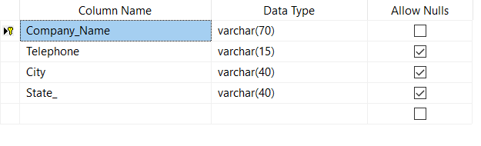

The Data Dictionary for the Nurse Table

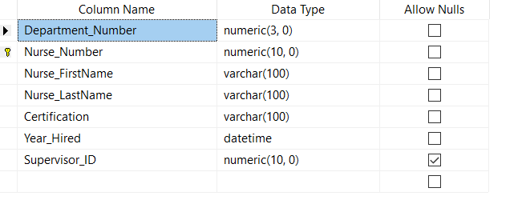

The Data Dictionary for the Operation Table

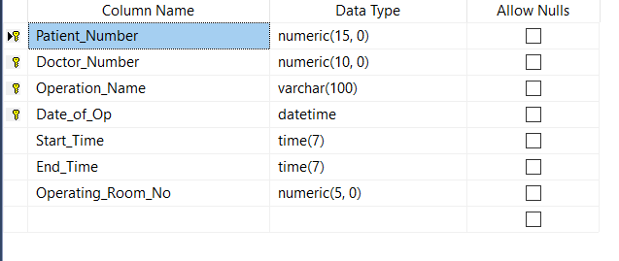

The Data Dictionary for the Operation_Type Table

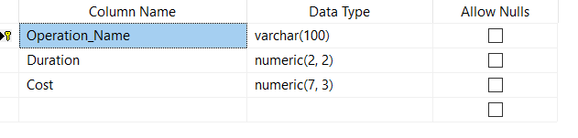

The Data Dictionary for the Patient Table

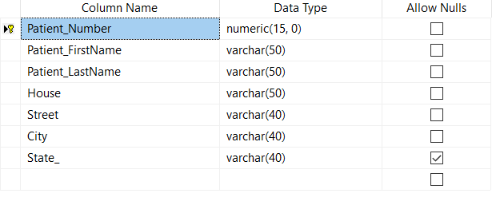

## Data generation and Loading:

--Insert data in Table Nurse

insert into Nurse values(110,'atif','aslam','Acute care Nurse Practitioner','2013-06-26',1000000010);

--Insert data in TABLE Doctor

insert into Doctor values(104,'Adam','Levigne',330,12343252345,1000000003)

--Insert data in TABLE Degree

insert into Degree values(1000000012,'Med','Dental','Harvard University',2012-03-06);

--Insert data in TABLE Operation_Type

insert into dbo.Operation_Type values('Carotid2',.9,34.32);

--Insert data in TABLE Patient

insert into Patient values('Charles','Darwin',34,'jayson str','Miami','Florida');

--Insert data in TABLE Patient

insert into Patient values('Charles','Darwin',34,'jayson str','Miami','Florida');

--Insert data in TABLE Operation

INSERT INTO DBO.Operation VALUES (100000000000006,1000000004,'Dilation and curettage',

'2018-05-19',

'12:12:43','03:09:06',735);

--Insert data in TABLE Insurance_Company

insert into Insurance_Company values('LifeInsur',8378298748,'Boston','Massachusets');

--Insert data in TABLE Claim

insert into Claim values ('Highmark Group',100000000000003,'Dental',127.23);

# Performance Tuning:

## Indexing

Table-1: “Nurse” Table in Hospital

Table-2: “Nurse_Dummy” Table in Hospital

Created a dummy table named Nurse_Dummy.

Query: CREATE TABLE Nurse_dummy (

Nurse_Number INT NOT NULL,

);

Create an Index on “Nurse_Number” in the new table “Nurse_Dummy”

CREATE INDEX idx_Nurse_Number ON Nurse_dummy(Nurse_Number);

TO Get the CPUTime we used a query called EXEC sp_who2;

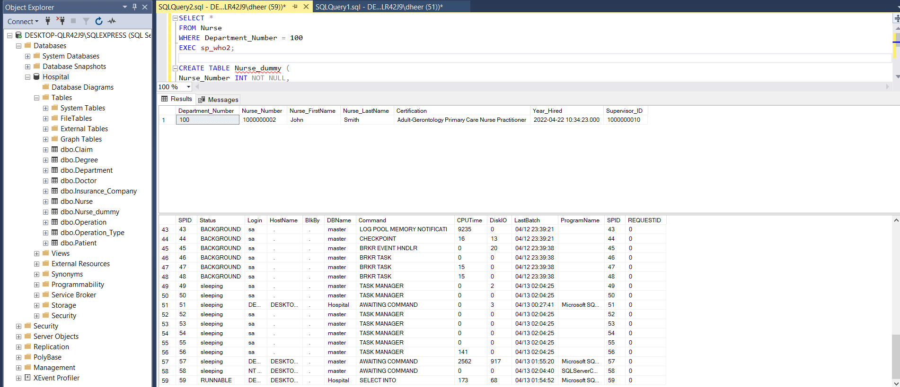

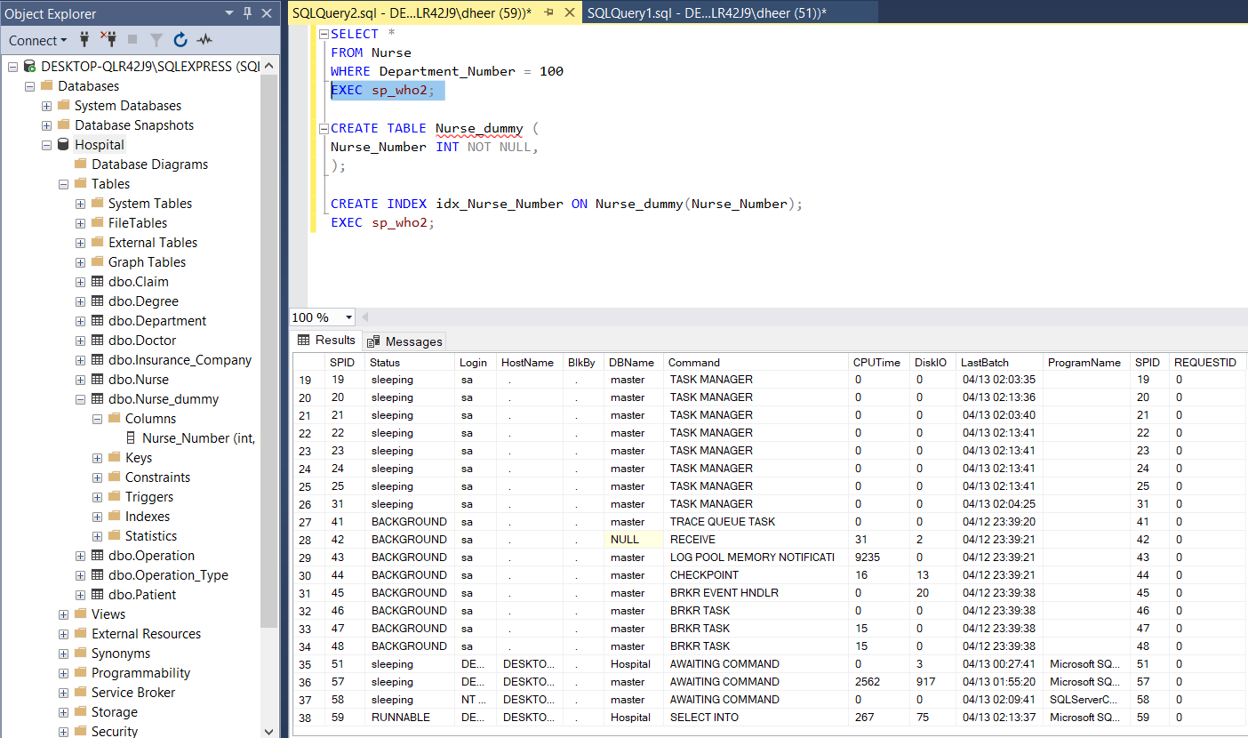

From the above, we see that when index is created on “Nurse_Number” column, for a query that requires accessing “Nurse_Number” column, the cost (% CPU) for the 2nd picture which is less than 1st picture for the same query for the table without index.

For the next to find the performance we have created a test table and inserted some sample data into so that we can be able to check the performance before adding a primary key and below are the some of the results.

1. Created a table with a unique constraint:

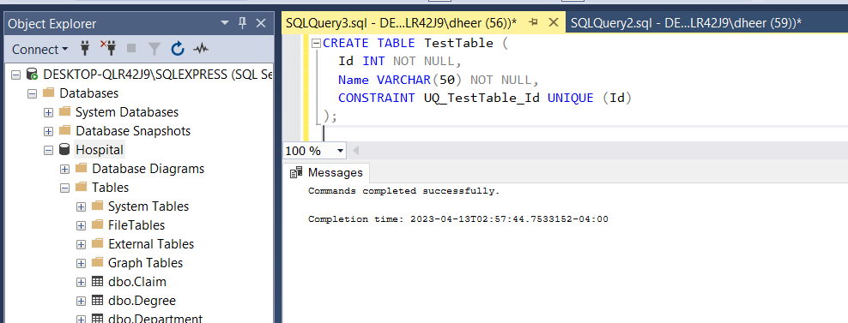

1. Inserted some sample data:

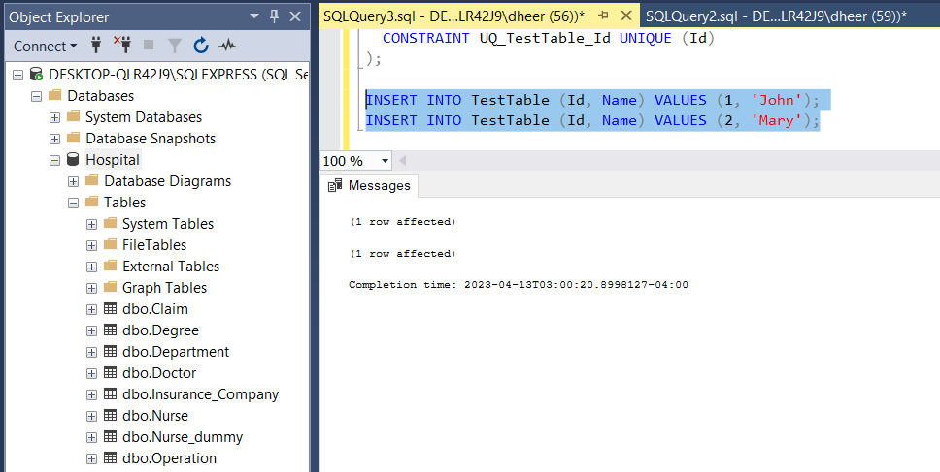

1. Run a SELECT query and examine the execution plan

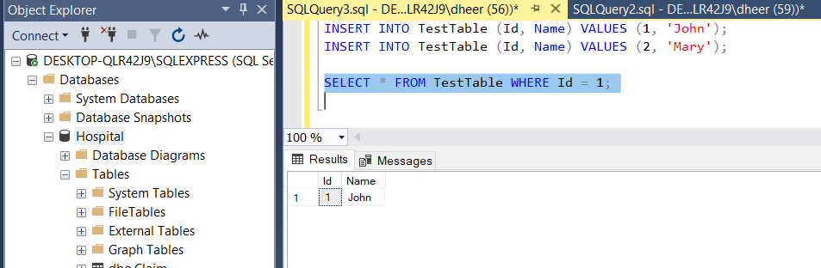

1. Before creating the primary key

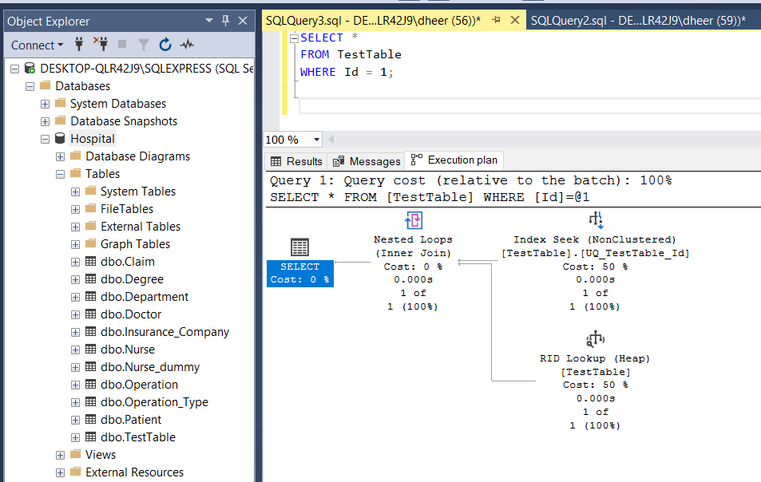

1. After adding a primary key constraint to the table using a query:

ALTER TABLE TestTable ADD CONSTRAINT PK_TestTable PRIMARY KEY CLUSTERED (Id);

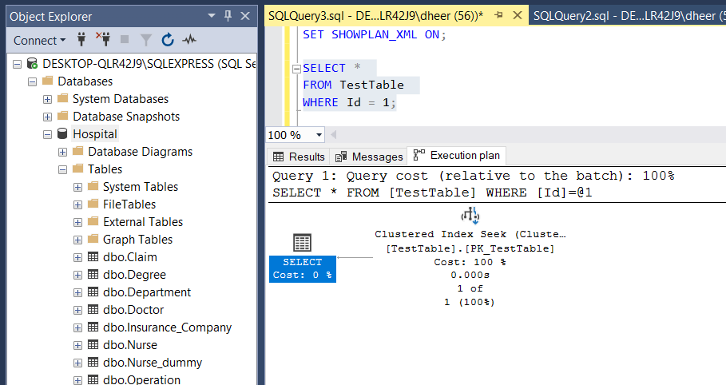

Thus, we can observe that TestTable_Id with no primary key added has more cost when compared to TestTable_Id with Primary key. So, the preferred one is option with primary key.

# Query Writing:

**Total number of doctors studied at Harvard University**

SELECT Doctor_FirstName, Doctor_LastName, University

FROM Doctor

INNER JOIN Degree

ON Doctor.Doctor_Number = Degree.Doctor_Number

WHERE Degree.University LIKE '%Harvard%';

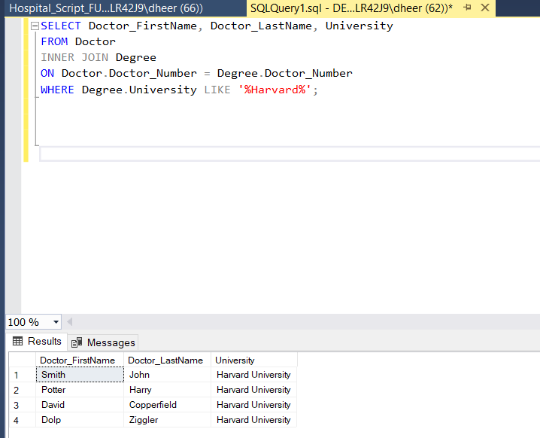

**Patients who have operation Dilation and curettage:**

SELECT Patient_FirstName, Patient_LastName, Operation_Name

FROM Patient

INNER JOIN Operation

ON Operation.Patient_Number = Patient.Patient_Number

WHERE Operation.Operation_Name LIKE '%Dilation%';

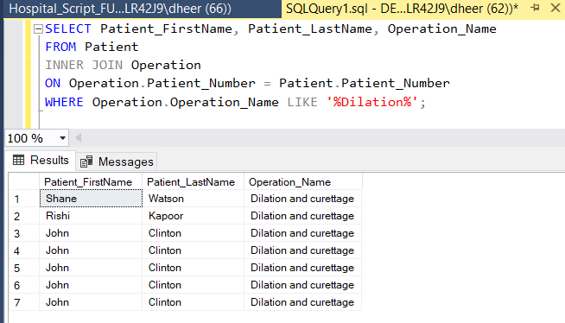

**Nurses who joined after 2020:**

SELECT *

FROM Nurse

WHERE Year_Hired BETWEEN '2019-01-01 00:00:00.000' AND '2022-12-01 00:00:00.000';

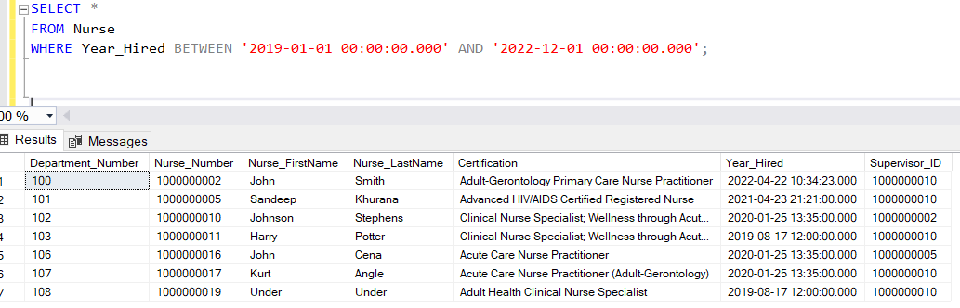

**Number of Insurance company operating:**

SELECT Count(*) FROM Insurance_Company;

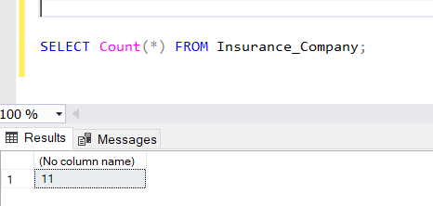

# Data visualisation:

# Conclusion: